Bleak News for Americans' Income
Pay Fell 7% in Last Decade and Economists Say It Won't Catch Up Before 2021; Even College Graduates See Salaries Slide
By PHIL IZZO

OCTOBER 14, 2011

Americans' incomes have dropped since 2000 and they aren't expected to make up the lost ground before 2021, according to economists in the latest Wall Street Journal forecasting survey.

From 2000 to 2010, median income in the U.S. declined 7% after adjusting for inflation, according to Census data. That marks the worst 10-year performance in records going back to 1967. On average, the economists expect inflation-adjusted incomes to rise over the next decade, but the 5% projected gain isn't enough to reach prerecession levels.
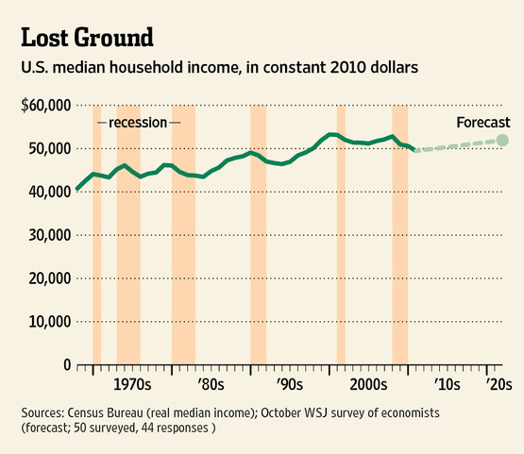

"Standards of living in the U.S. will continue to decline as we deleverage and emerging markets take over as the growth engine of the global economy," says Julia Coronado of BNP Paribas.

Though the majority of the 50 economists surveyed-not all of whom answer every question-say the current generation of college graduates will have a higher standard of living than their parents, a third of respondents think it will be lower. College graduates have generally fared better in the U.S., and they currently have a 4.2% unemployment rate compared to 9.1% for the entire work force. But a college degree hasn't been enough to ensure wage gains from 2000 through 2010. According to Census Bureau data, only advanced degree holders managed to record increases in earnings over that period.

The current generation of college graduates will only see a higher standard of living if "they get graduate degrees and are willing to give up a lot of free time," says Diane Swonk of Mesirow Financial. She says that while falling incomes may make up lost ground, the issue will be the distribution of those gains.

Incomes are being held down by persistently high unemployment and tepid economic growth, and the situation isn't expected to improve much in the foreseeable future. "What might be the locomotive?" asks Edward Leamer of UCLA Anderson Forecast. Typical drivers of economic recovery haven't been robust. Housing remains stuck at recessionary levels with home prices expected to be nearly flat next year while construction is stuck at recessionary levels. Manufacturing and consumer spending have improved over the course of the recovery but haven't been rising at levels that would lead to vigorous expansion. Meanwhile, growing global concerns could depress export markets.

Economic growth for 2011 is expected to be just 1.5%, accelerating to 2.3% next year and 2.7% for 2013. But that slow pace won't be enough to bring down the unemployment rate quickly. On average, the economists expect the economy to add just 1.5 million jobs over the next 12 months, barely enough to keep up with population growth. They forecast the jobless rate will be at 8.2% at the end of 2013, a decline of less than one percentage point over more than two years.

Those numbers could look even worse if the U.S. falls into a recession. The economists, on average, put nearly 1-in-3 odds of another downturn hitting the U.S. economy in the next 12 months. The uncertain international picture could weigh on U.S. growth. Amid a debt crisis in Europe, the economists put better than 50-50 odds of a recession in the euro zone over the next year.

Respondents put 83% odds on Greece failing to meet its debt obligations, while they see a 59% chance of Portugal being unable to pay all its bills in full. Among other highly indebted euro-zone countries, the odds are 46%, 37% and 34% for Ireland, Spain and Italy, respectively. These numbers translate into better than a 1-in-3 chance of at least one member leaving the euro currency union in the next two years, according to the economists.

